Post Campaign Report
MorenoMusics.com

In our campaign we marketed the Moreno Music sound studio. This studio offers a few different kinds of services to different crowds from both Israel and abroad. One of the services is the Mastering service that can be offered to both crowds and the rest of the services such as recording and mixing can be offerd to the Israeli crowd only.
In our campaign we addressed these two crowds by writing ads in Hebrew for the local crows and ads in English for the international crowd.
At the beginning of the campaign we conducted a "research week" in order to find out what ads work best and mostly to know which one of the crowds is more relevant. After this week we were planning to balance the different crowds so that the relevant one had more money invested in. After this week we saw that the Hebrew ads were very low on traffic and we did not need to make any kind of leveling of the money invested to each crowd because although the local crowd section had many adgroups it did not consume much money due to the low traffic.
The main goal of the campaign was to increase traffic in the website from international potential customers. Ofcourse we aimed for the highest CTR and the lowest CPC possible. In order to achieve this we chose the lowest cost per click that would give us a reasonable ranking. The words we were aiming at were not cheap ones for the market of mastering is a saturated one and there are many competitors for these words. The way we chose how to price our words were by the aid of the adWords website. In order to get a high Click thru rate, we wrote different texts for ads and we were planning to choose the best one but they had all received roughly similar ratings so we kept them all running.
Our campaign began on May 28th until June 14th and during this time we had spend the entire budget of 250$.
We had 8 different adGroups, two for international crowd and six for natiol crowd. The national ones are:
- הפקה מלאה
- הקלטה אנלוגית
- הקלטות
- הקלטות חיות
- מאסטרינג
- מיקס

The international are:
- Analog Mastering
- Mastering
In order to monitor our campaing every day we logged in and checked if there is a need to adjust our CPC according to changes in the adwords system.
Our campaign had begun with two main objectives but after the first week we realized that the Israeli objective is not with a high potential of succeeding and the focus was shifted to only the international objective – like we said before this was done "automatically" because there was no traffic for the Hebrew words.
Another aspect that we dealt with was the web site. We added a new page specifically designed for international potential Mastering costumers. This site was added as the link of the ads that were in English. The new site made it easier for people who clicked the ad to contact the studio and to read about the service of mastering that the studio provides.

Mastering AdGroup:

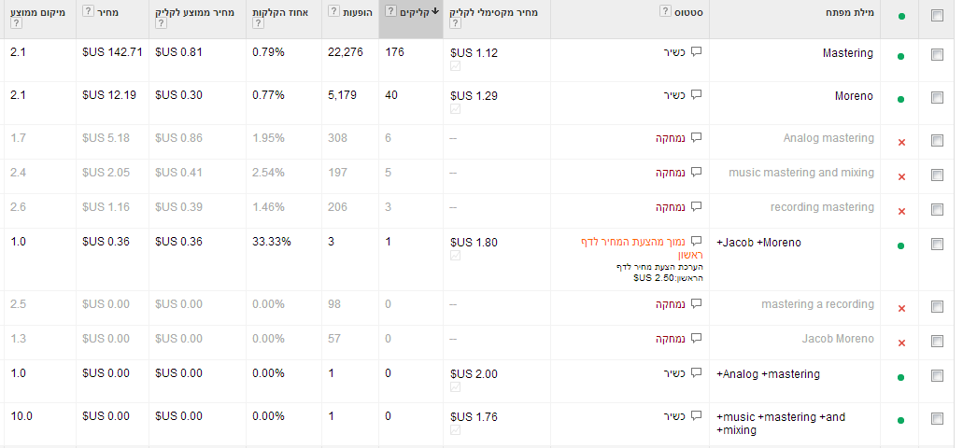

As can be seen in the photo, key-words with low traffic were deleted.

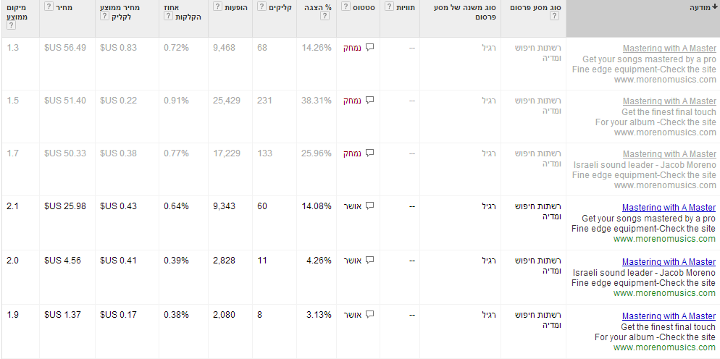
The deleted texts are same like the working ones only that the website was changed so it is shown as deleted. The data should be looked at as if summed.

Analog Mastering adGroup:
Here you can see the data of the analog group

הפקה:

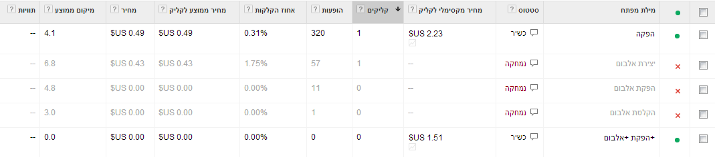
You can see how the Hebrew key words had very low traffic and a very low click rate aswell, even after some changes were made, it didn’t seem to get any better.

הקלטה אנלוגית:

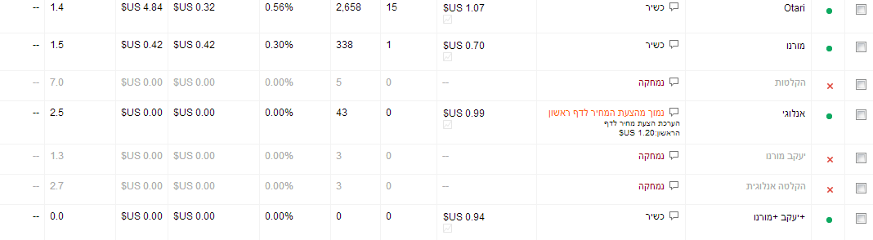
Here aswell you can see the data of the Hebrew keywords.

In the remaining Hebrew adGroups the situation as mainly the same, there isn’t a lot of traffic nor are there many clicks.

Here is a summery of the entire campaign :
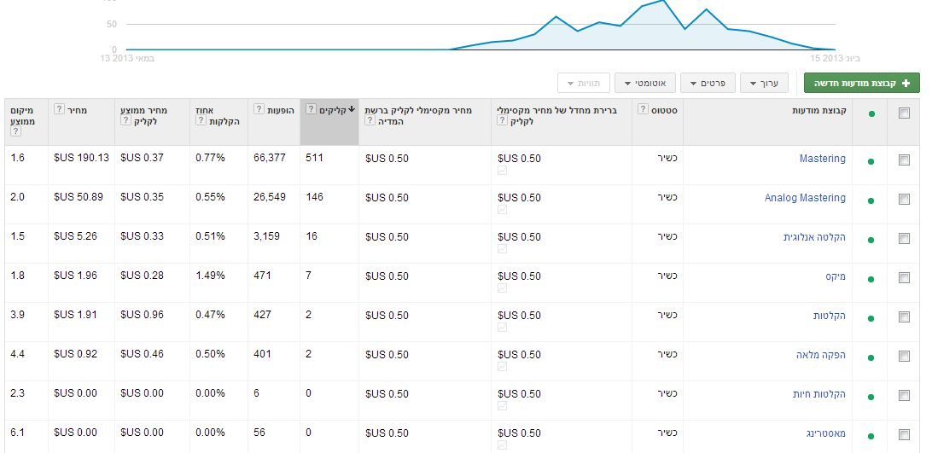
Total number of clicks was 684
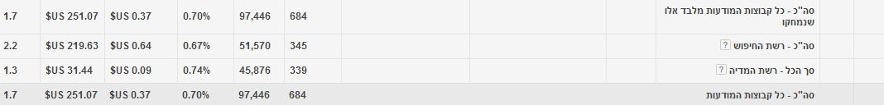
So it can be said that the average price per click was 0.36 $ US.

Seems like a price of 0.36 per click is a good one. Because one customer that would decide to get the mastering service would pay around 100$ per song and usually would do at least a few songs at a time so if lets say 400$ is a costumers average pay so it seems that 0.36 is a good price for marketing.
The Moreno Music Campaign was a successful one. The market is very active and it is not easy to get clicks. We had used both the Media and Search networks for the adwords campaign. With this campaign the awareness did increase and the website was developed to answer the needs of the client.
We had hoped to learn about the mechanism of the adWords world and how to run a successful campaign as a team, how to monitor changes in real time in the campaign and act accordingly. We did not anticipate that clicks would be so expensive and we had hoped to get a higher number of clicks when we started but we soon learnt and understood that clicks can be very expensive when you have many people fighting over them. As a group we had a very good connection and we did not encounter any problems, we were all very professional and each member had taken care of his responsibilities. When meeting the client we did not encounter any problems aswell, he was very nice to us.
Our group had learned a lot about the world of online trading and marketing, on the adgroups system and advertising in the internet in general.
We will advise Moreno Music with regards to future investments in adwords campaign and we will also offer ourselves for prolonging the campaign in the near future. We will advise Moreno Music to concentrate in the international Mastering field and also advise to take his web site to even a higher level where a client would find it super easy to feel like a process with Moreno Music Studios had already begun when he entered the web site.

