Advanced Topics in Computational and Combinatorial Geometry

Assignment 1 (short answers and hints)

Problem 1
a) It is easy to see that each such $U_{T}$ is a Davenport-Schinzel sequence of order 2 (an a..b..a..b would imply that two chords cross one another). Notice that the size of each $U_{T}$ is $2n-3$ . Since $λ_{2}\left(n-1\right)=2n-3$ we can conclude that $U_{T}$ is of maximum length.
b) First notice that the last appearing symbol in a DS sequence of order 2 appears only once. Also if $n$ is the last symbol then a maximal sequence looks locally like $\left[x\right]\left[n\right][x]$. Now using induction we construct a polygon for the sequence without the $\left[n\right][x]$ part. Now add a new vertex named [n], connect it to 0 and $n$. Reconnect vertex [n] only to the vertices that are after the [n-1] symbol and before the [n] symbol. Connect the [n+1] vertex to all the vertices that are after the [n+1] symbol.
c) see this: www.math.nmsu.edu/hist_projects/catalan.ps ( you need to download some program to see postscript files)

Problem 2
a+b: For $n=6$. 1213141515432626364656 of length 5*6-8

For larger $n$ this is done similarly.

Problem 3
a) First, construct the lower envelope of each $F_{i}$ separately. Total complexity so far: ${\sum_{i=1}^{c}{λ_{s_{i}+2}\left(n_{i}\right)≤}λ}_{q+2}(n)$. Now merge the x-values of all the critical points on the lower envelope of the separate $F_{i}$'s. we get a total of at most $λ_{q+2}(n)$ such x-values. Consider these x-values: $-∞<x_{1}<x_{2}<x_{3}<…<x_{k}<∞$ . Between any two consecutive x-values: $x_{i}<x_{i+1}$ there are only c different functions, one from each collection, that can attain the envelope, so the number of new critical points created from intersections between them is at most O(1).
Thus the total complexity is $O(λ_{q+2}\left(n\right))$.
b) The construction of the lower envelope for each $F_{i}$ takes $O(λ_{s_{i}+1}\left(n_{i}\right)\log\left(n_{i}\right))$ time. Merging the sorted x-value lists for each $F_{i}$ into one big x-value list for all $F_{i}$'s takes $O(λ_{q+2}\left(n\right))$ time. Constructing the additional O(1) points over each interval takes O(1) time, and in total $O(λ_{q+2}\left(n\right))$. Thus the algorithm takes $λ_{q+1}\left(n\right)log⁡(n)$ time. (We use the fact that $λ_{q+2}\left(n\right)=O(λ_{q+1}\left(n\right)\log\left(n\right))$.)
c) Here q=1 thus $λ_{3}\left(n\right)$.

Problem 4
a) A line crosses a triangle $Δ=abc$ iff it passes below at least one of a,b,c, and above at least one of these points. In the dual, $l^{*}$lies between the upper envelope $U_{Δ}$ and the lower envelope $L_{Δ}$ of the three lines $a^{*}, b^{*}, c^{*}$. The shape of the region is one of the following:
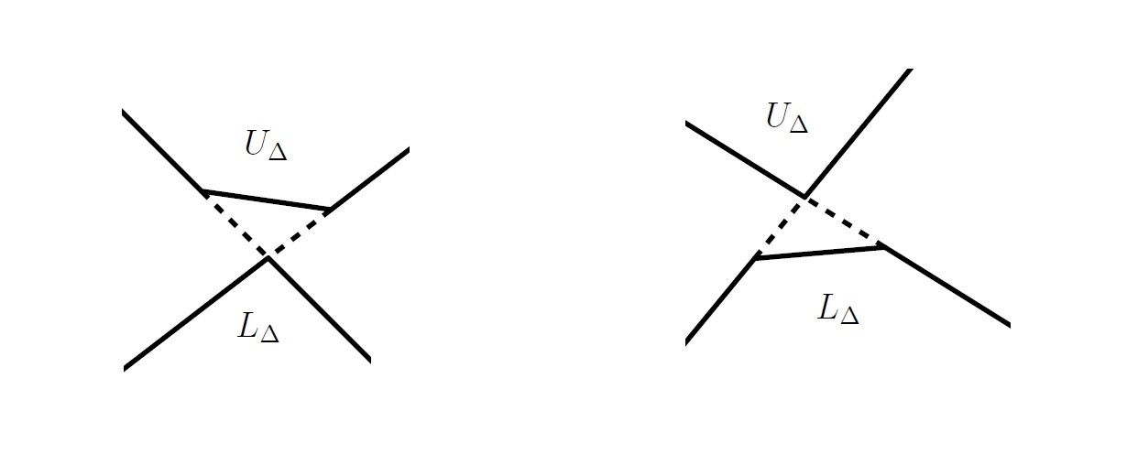
b+c) As in a), $l^{*}$ must lie below all upper envelopes $U_{Δ}$ and above all lower envelopes $L_{Δ}$. Each of these "full" envelopes is the lower/upper envelope of at most 3n segments and rays, so its complexity is at most $λ_{3}\left(3n\right)=O(nα\left(n\right))$. This implies that the complexity of the "Sandwich region" between them is also $O(nα\left(n\right))$.

