SharirFest 2010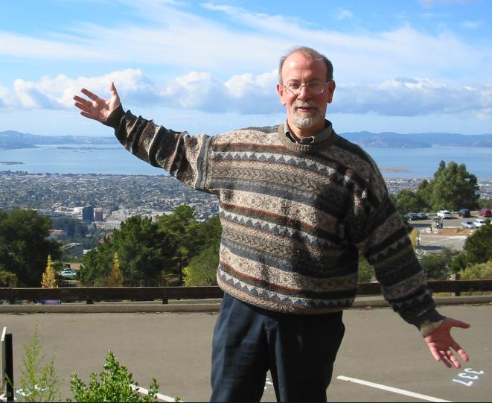
Sunday, May 23rd, 2010.
Tel-Aviv University, Israel.
Schreiber building Room 006 (Ground floor, close to the entrance).
Born in 1950 at Tel Aviv, Micha Sharir received his Ph.D. in Mathematics from Tel Aviv University in 1976, and then switched to Computer Science, doing his postdoctoral studies at the Courant Institute of New York University. He returned to Tel Aviv University in 1980, where he currently holds the Nizri Chair in computational geometry and robotics in the School of Computer Science. He has served as the Head of the Computer Science Department at Tel Aviv University (twice) and as the head of the School of Mathematics (1997-99). He is one of the co-founders of the Minerva Center for Geometry at Tel Aviv University. He is also a Visiting Research Professor at the Courant Institute.
Over the last three decades, Micha has made fundamental contributions to a wide range of areas in computer science and mathematics, from computational and combinatorial geometry to robotics, and from functional analysis to programming languages. He pioneered the field of algorithmic motion planning, profoundly influenced the field of geometric algorithms, and developed strong ties between computational and combinatorial geometry. A recipient of several awards, including the Max-Planck research prize, the Feher Prize, the Mif'al Hapais' Landau Prize, the EMET Prize, and honorary doctorate degree from the University of Utrecht, Micha has authored four books and more than 400 research articles. He has supervised more than 20 Ph.D. students, many of which are now at various stages of their academic careers, in Israel and abroad.

Organizers
Pankaj Agarwal, Duke University
Boris Aronov, Polytechnic Institute of NYU
Dan Halperin, Tel Aviv University
Haim Kaplan, Tel Aviv University
Matya Katz, Ben-Gurion University

The schedule of the event:
10:00 am - 10:15 am | Opening Remarks (Haim Wolfson)
10:15 am - 11:00 am | Pankaj K. Agarwal, Duke University  An Odyssey beyond Flatland: Arrangements, Envelopes, and Unions (abstract)
11:00 am - 11:15 am | Break
11:15 am - 12:00 pm | Raimund Seidel, Saarland University  Issues in Geometric Rounding (abstract)
12:05 pm - 12:50 pm | Klara Kedem, Ben-Gurion University  Perverse and Non-Perverse Geometry: from Hausdorff Distance to GPU (abstract)
12:50 pm - 14:15 pm | Lunch
14:15 pm - 15:00 pm | Sariel Har-Peled, UIUC  Finding Haystacks (and Other Structures) in Geometry (abstract)
15:05 pm - 15:50 pm | Dan Halperin, Tel-Aviv University  From Piano Movers to Piano Makers: Constructing and Deconstructing Minkowski Sums (abstract)
15:50 pm - 16:05 pm | Break
16:05 pm - 16:50 pm | Noga Alon, Tel-Aviv University  Hypergraph List Coloring and Euclidean Ramsey Theory (abstract)
The abstracts of the talks:

- Pankaj K. Agarwal, Duke University
An Odyssey beyond Flatland: Arrangements, Envelopes, and Unions
The arrangement of a finite collection of geometric objects is the decomposition of the space into connected cells induced by them. This talk will survey combinatorial and algorithmic results on arrangements, and their substructures, over the last 25 years, and how Micha has influenced this field.
- Noga Alon, Tel-Aviv University
Hypergraph List Coloring and Euclidean Ramsey Theory
It is well known that one can color the plane by 7 colors with no monochromatic configuration consisting of the two endpoints of a unit segment. In sharp contrast we show that for any finite set of points X in the plane, and for any finite integer k, one can assign a list of k distinct colors to each point of the plane, so that any coloring of the plane that colors each point by a color from its list contains a monochromatic isometric copy of X.
Joint work with A. Kostochka.
- Dan Halperin, Tel-Aviv University
From Piano Movers to Piano Builders: Constructing and Deconstructing Minkowski Sums
The Minkowski sum of two sets P and Q in Euclidean space is the result of adding every point in P to every point in Q. Minkowski sums constitute a fundamental tool in geometric computing, often in relation to motion planning (Piano Movers), as well as to many other problems. We survey results on the structure, complexity, algorithms, and implementation of Minkowski sums in two and three dimensions. We then consider the reverse, deconstruction, problem: Can a given shape be expressed as the Minkowski sum of certain types of objects. This question too arises in various domains and in particular in connection with wood-cutting machines (Piano Makers). We review a few recent results on the deconstruction question.
- Sariel Har-Peled, UIUC
Finding Haystacks (and Other Structures) in Geometry
One of the key ideas in geometric computing is the usage of small subsets that represents well the (considerably larger) original input. We will survey some notions in geometry that were defined to this end, including eps-nets, eps-approximations, relative approximations, and coresets.
- Klara Kedem, Ben-Gurion University
Perverse and Non-Perverse Geometry: from Hausdorff Distance to GPU
The title was inspired by an early 1990's quote distinguishing between non-perverse (pure) and perverse (applied) computational geometry. Applications can dominate a field, especially computational geometry which has so many of them, such as in computer games, bioinformatics, computer graphics, image processing and on and on. But as in the case of classical Euclidean geometry the pure intellectual contributions, for which Micha is known, are immeasurably more influential and lasting.
I will talk about my (non-perverse) work on the minimum Hausdorff distance with Micha and Dan Huttenlocher, and on my combined perverse and non perverse work with Dror Aiger (my recent PhD student) on partial point matching and its implementation in the GPU framework. I will briefly mention two applications from my work in bioinformatics and image processing which are based on distance measures between shapes.
I will take this opportunity to tell stories that only an advisee can tell about her PhD advisor.

- Raimund Seidel, Saarland University
Issues in Geometric Rounding
Loosely speaking, ``geometric rounding'' refers to approximating a geometric object by another one that admits a simple representation using ``simple'' coordinate values. An interesting example concerns approximating a plane straight-edge graph by another one whose vertices have real coordinates that can be expressed as fixed point numbers using few bits. Already this seemingly easy example raises a number of interesting algorithmic and complexity questions. I will address some of them.

